Practical 1: Intelligent Agents

What is an Intelligent Agent?
An Intelligent Agent is a computer program that:
- Perceives (observes) its environment.
- Thinks (decides what to do).
- Acts (performs an action).
For example:
- Google Maps suggests the shortest route.
- A robot vacuum cleans your house.
- Siri and Alexa answer your questions.
An intelligent agent follows the cycle:
Perception → Decision → Action

Example: Vacuum Cleaner Agent
Suppose we have two rooms:
+---------+---------+
| A | B |
| | |
+---------+---------+
Each room can be:
- Clean
- Dirty
The vacuum cleaner (agent) can perform three actions:
- Suck
- Move Left
- Move Right

Simple Reflex Agent

Concept
A Simple Reflex Agent makes decisions only based on the current situation.
It does not remember anything.
It simply follows IF–THEN rules.
For example,
IF room is dirty
THEN Clean it

ELSE
Move to another room
There is no memory.

Code
def simple_reflex(location, status):

if status == "Dirty":
return "Suck"

elif location == "A":
return "Move Right"

else:
return "Move Left"
Let's understand each line.

Line 1
def simple_reflex(location, status):
We create a function named simple_reflex().
It accepts two inputs:
- location
- status
Example:
Location = A

Status = Dirty

IF Condition
if status == "Dirty":
The agent checks
"Is the current room dirty?"
If Yes
Action = Suck

Return Statement
return "Suck"
The vacuum cleans the room.

Else If
elif location == "A":
Suppose room A is already clean.
Then
Move to room B.
Return Move Right

Else
return "Move Left"
If the agent is already in room B
it moves back to room A.

Main Program
location = "A"
status = "Dirty"

action = simple_reflex(location,status)

print(action)
Initially
Agent is in Room A

Room A is Dirty
Function call
simple_reflex("A","Dirty")

Inside function
Is room dirty?

YES
Return
Suck
Output
Suck

Draw this on the board
Current Room

↓

Dirty?

↓

YES

↓

Clean (Suck)

↓

Stop
No memory.

Limitation of Simple Reflex Agent
Suppose yesterday
Room A was cleaned.
Today
Agent again receives
Location = A

Status = Dirty
It doesn't know
whether it cleaned the room before.
It has no memory.
This is the biggest limitation.

Model-Based Reflex Agent
Now ask students:
How can we make the agent smarter?
Answer:
Give it memory.

Concept
A Model-Based Agent stores information about the environment.
Example
Room A = Clean

Room B = Dirty
This information is stored in memory.

Code
environment = {

"A":"Dirty",

"B":"Dirty"

}
This is called the internal model.
Initially
Room A Dirty

Room B Dirty

Function
def model_based_agent(location):
Unlike the previous function,
we don't need status.
Why?
Because the agent already remembers the environment.
It checks
environment[location]

First Condition
if environment[location]=="Dirty":
Suppose
Current room = A
Environment says
A = Dirty
Then

environment[location]="Clean"
This line updates memory.
Earlier
A = Dirty
Now
A = Clean
Memory is updated.

Then
return "Suck"
Vacuum cleans the room.

Second Condition
if location=="A":
Suppose room A is already clean.
Move to room B.
Return Move Right

Else
return "Move Left"
If currently in room B
Move back to A.

Main Program
current="A"
Initially
Vacuum starts in Room A

Loop
for i in range(6):
Run six steps.

Step 1
action=model_based_agent(current)
Current
A
Environment
A Dirty
Action
Suck
Memory becomes
A Clean

B Dirty

Print
Location A

Action Suck

Environment

A Clean

B Dirty

Move
Action is
Suck
So
Current location remains A.

Step 2
Again function called.
Now
Environment says
A Clean
Not dirty.
Hence
Move Right
Now
Current=B

Step 3
Current
B
Environment
Dirty
Action
Suck
Environment becomes
A Clean

B Clean

Step 4
Current
B
Already clean.
Move Left.
Current becomes
A

Step 5
Current
A Clean
Move Right.

Step 6
Current
B Clean
Move Left.

Complete Execution Table
Step | Current Room | Room Status | Action | Memory After Action
1 | A | Dirty | Suck | A=Clean, B=Dirty
2 | A | Clean | Move Right | A=Clean, B=Dirty
3 | B | Dirty | Suck | A=Clean, B=Clean
4 | B | Clean | Move Left | A=Clean, B=Clean
5 | A | Clean | Move Right | A=Clean, B=Clean
6 | B | Clean | Move Left | A=Clean, B=Clean

Code:

def simple_reflex(location, status):

"""

Simple Reflex Agent

Makes decisions only based on the current input.

It has no memory.

"""

if status == "Dirty":

return "Suck"

elif location == "A":

return "Move Right"

else:

return "Move Left"

print(" SIMPLE REFLEX AGENT ")

location = "A"

status = "Dirty"

action = simple_reflex(location, status)

print("Current Location :", location)

print("Room Status :", status)

print("Action :", action)

print("\n\n MODEL-BASED REFLEX AGENT ")

environment = {

"A": "Dirty",

"B": "Dirty"

}

def model_based_agent(location):

if environment[location] == "Dirty":

environment[location] = "Clean"

return "Suck"

elif location == "A":

return "Move Right"

else:

return "Move Left"

current = "A"

for step in range(1, 7):

action = model_based_agent(current)

print("\n ")

print("Step :", step)

print("Current Room :", current)

print("Action :", action)

print("Environment :", environment)

if action == "Move Right":

current = "B"

elif action == "Move Left":

current = "A"

Output:

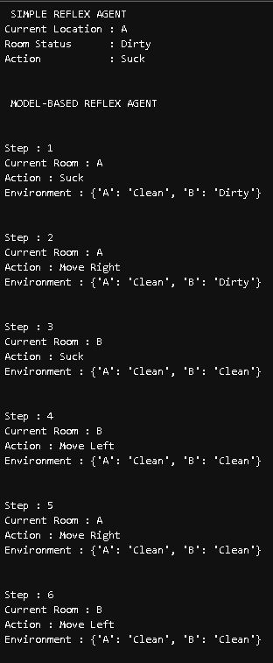

Difference Between the Two Agents
Simple Reflex Agent | Model-Based Reflex Agent
No memory | Has memory
Uses only current input | Uses current input + stored state
Cannot remember previous actions | Remembers previous actions
Suitable for fully observable environments | Suitable for partially observable environments
Simpler to implement | More intelligent and flexible

- Simple Reflex Agent: Imagine a person who enters a room, looks around, and cleans it if it is dirty. After leaving, they forget everything. If they come back later, they have no memory of whether they cleaned it before.
- Model-Based Reflex Agent: Imagine a person carrying a notebook. After cleaning Room A, they write "Room A – Clean." When they return, they check the notebook before deciding what to do. The notebook is the agent's internal model (memory).
This analogy clearly illustrates why a model-based reflex agent makes more informed decisions than a simple reflex agent.

